Zermatt VM Guide
(Zermatt V3.0.1)
Whilst all reasonable care has been taken to ensure that the details are true and not misleading at the time of publication, no liability whatsoever is assumed by Automature LLC, or any supplier of Automature LLC, with respect to the accuracy or any use of the information provided herein.
Any license, delivery and support of software require entering into separate agreements with Automature LLC.
This document may contain confidential information and may not be modified or reproduced, in whole or in part, or transmitted in any form to any third party, without the written approval from Automature LLC.
Copyright © 2010 Automature LLC
All rights reserved.
Revision History
Ver. | Date | Name | Description of Changes
2.6 | 30-08-2011 | Dipayan Sengupta | First Edition
2.6 | 02-09-2011 | Dipayan Sengupta | Second Edition
3.0.1 | 06/11/12 | Soham Ghosh | Third Edition
Contents
1 Introduction 4
1.1 Document Purpose 4
1.2 Intended Audience 4
2 Virtual Machine Configuration 5
2.1 Change the IP Address of the virtual machine. 5
2.2 Change the Host name of the virtual machine. 5
3 TWiki Port Configuration (If required) 7
3.1 Steps to configure TWiki Port 7
4 Apache Port Configuration (If required) 8
4.1 Steps to configure Apache Port 8
5 Zermatt configuration 9
5.1 Steps to configure Zermatt 9
6 MySQL configuration 10
6.1 Steps to configure MySql. 10

Introduction

- Zermatt is a web server application that has been developed using Perl, MySQL, Apache, TWiki and TML (TWiki Markup Language). Zermatt helps you to plan and report the QA processes of an organization.
- VMware Player is a freeware virtualization software package from VMware, Inc

1.1 Document Purpose

- The Configuration Guide provides step by step instructions for configuring Zermatt in a Virtual Machine.

1.2 Intended Audience

- This Configuration Guide is intended for system administrators, who would be installing and managing Zermatt.

2 Virtual Machine Configuration

2.1 Change the IP Address of the virtual machine.
- On the fresh copy of zermatt virtual machine change the IP address of the virtual machine.
sudo pico /etc/network/interface
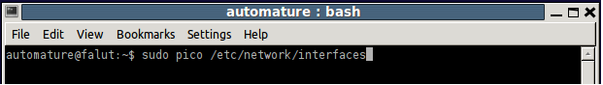

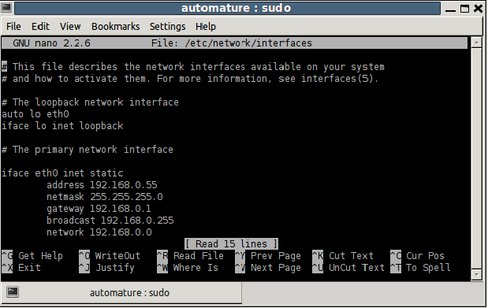

2.2 Change the Host name of the virtual machine.

- Change the Host name of the virtual machine
sudo pico /etc/hostname

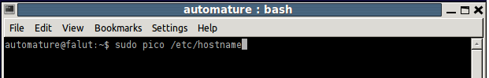

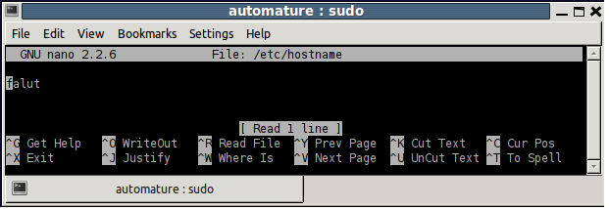

3 TWiki Port Configuration (If required)

3.1 Steps to configure TWiki Port

- To configure TWiki login to http://localhost:21680/twiki/bin/configure

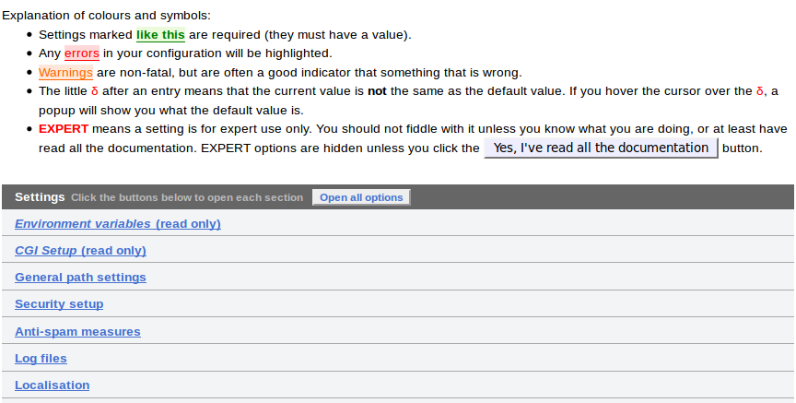
- Enter password and configuration screen will appear. In configuration screen click on “General path settings”.

- Add port to DefaultUrlHost and PermitteRedirectHostUrls.
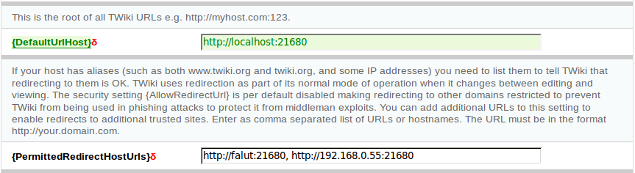

- Click next and click save to complete the process.

4 Apache Port Configuration (If required)

4.1 Steps to configure Apache Port

- To configure Apache port open console and type :
sudo pico /ctc/apache2/ports.conf
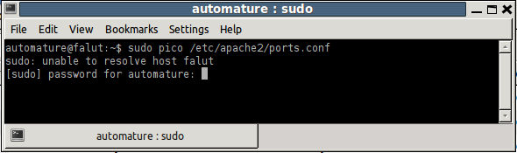

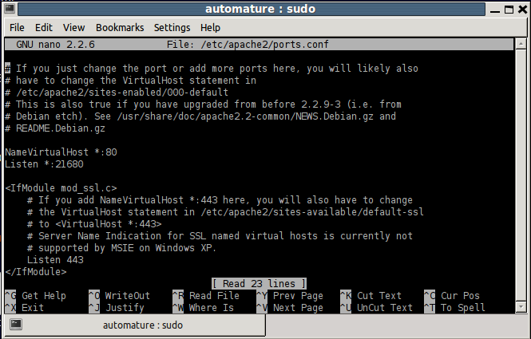
- Restart Apache : sudo service apache2 restart
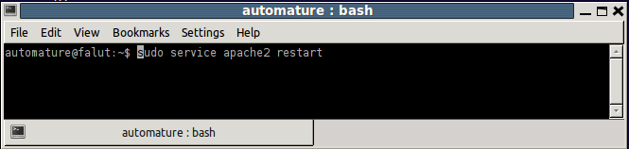

5 Zermatt configuration

5.1 Steps to configure Zermatt
- To verify zermatt login open the web browser and type http://192.168.0.55:21680/twiki/bin/view press enter and login with userid and password.
- Download zermatt Archive from FTP.
- Change directory to place the zermatt Archive file downloaded location, move zermatt archive to /var/www/twiki
sudo mv zermatt–twiki–v3.0.2.tar.gz /var/www/twiki
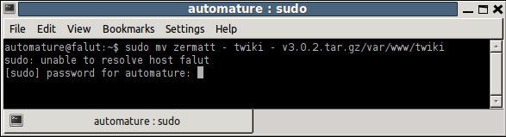
- To unzip the zermatt download Archive type
tar –xvzf zermatt–twiki-v3.02.tar.gz

6 MySQL configuration

6.1 Steps to configure MySql.
- To change MySql bind address type : sudo etc/mysql/my.conf
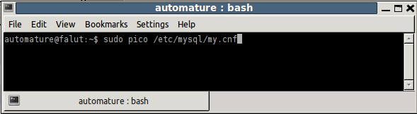

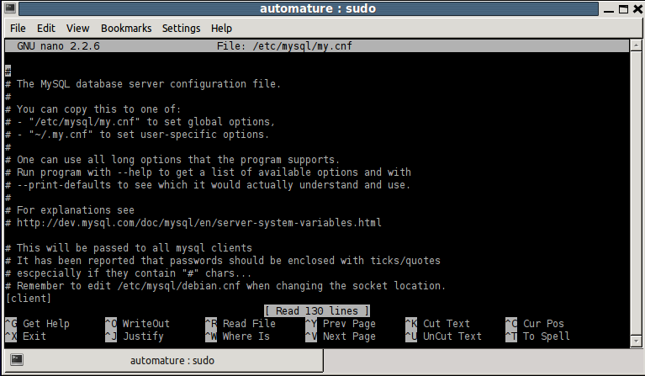
- Download my sql Archive from FTP.
- To move My Sql file to proper location type
sudo mv MySQLdatav3.0.2.tar.gz /var/www/twiki
- To unzip the MySQL downloaded Archive file type
sudo tar -xvzf MySQLDatav3.0.2.tar.gz
- To execute the file with in MySQL Archive file
mysql -u root -p Framework<ZermattSchema.v3.0.2.sql
mysql -u root -p Framework<ZermattReferenceData.v3.0.2.sql
- To login to my sql type mysql –u root –p
- Press enter and give password to login.

